New England Colonies
Colonies- Massachusetts, New Hampshire, Rhode Island, Connecticut
Climate/Geography – Colonists in the New England colonies endured bitterly cold winters and mild summers. Land was flat close to the coastline but became hilly and mountainous farther inland. Soil was generally rocky, making farming difficult. Cold winters reduced the spread of disease.
Religion – The New England colonies were dominated by the Puritans, reformers seeking to “purify” Christianity, who came over from England to practice religion without persecution. Puritans followed strict rules and were intolerant of other religions, eventually absorbing the separatist Pilgrims in Massachusetts by 1629. Life in New England was dominated by church, and there were severe consequences for those who failed to attend, or, those who spoke out against the Puritan ways. Singing and celebrating holidays were among things prohibited in Puritan New England.
Economy – New England’s economy was largely dependent on the ocean. Fishing (especially codfish) was most important to the New England economy, though whaling, trapping, shipbuilding, and logging were important also. Eventually, many New England shippers grew wealthy buying slaves from West Africa in return for rum, and selling the slaves to the West Indies in return for molasses. This process was called the “triangular trade.”
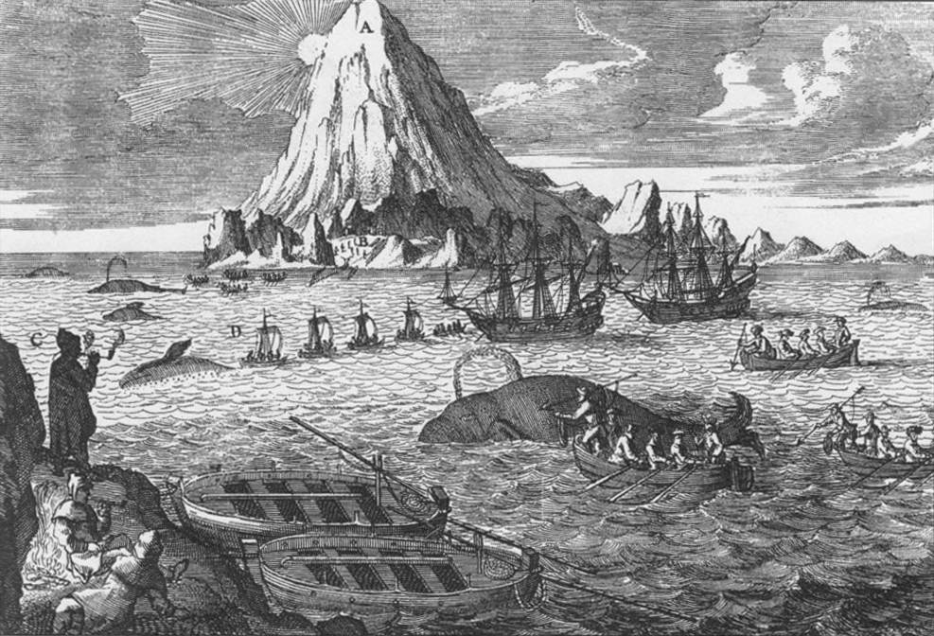
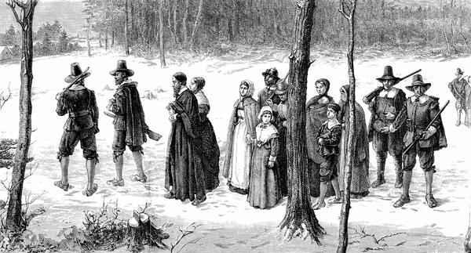
Important Founders:
William Bradford (Plymouth Colony in Massachusetts)
William Bradford was an English Separatist (Pilgrim) leader in Plymouth Colony. He was a signer of the Mayflower Compact and served as Plymouth Colony Governor five times covering about thirty years between 1621 and 1657.
Roger Williams and Anne Hutchinson (Rhode Island)
Williams and Hutchinson were residents of Puritan Massachusetts Bay Colony. They began to preach ideals that the Puritans didn't agree with. Williams came first and was banished. He went south and founded Rhode Island. Hutchinson came later and when she was banished, she joined Williams in Rhode Island.
Roger Williams believed that the Massachusetts Colony needed to tolerate different religious beliefs and the church and government should be separate. Roger fled Massachusetts and found the settlement of Providence. Later, it became the colony of Rhode Island it was the first European colony to allow people to different religious beliefs (Religious tolerance).
Anne Hutchinson was brought to trial in Massachusetts because she believed people should pray directly to God rather than depend upon church teachings. She was forced to leave Massachusetts so she traveled to Rhode Island and started the settlement of Portsmouth.
Thomas Hooker
Thomas Hooker was a prominent Puritan colonial leader, who founded the Colony of Connecticut after disagreeing with Puritan leaders in Massachusetts. He believed in government by the people, for the people. Connecticut ratified the Fundamental Orders of Connecticut which would be the first written constitution in America. It marked the beginnings of American democracy, and Thomas Hooker was a major influence on it. The government of the United States today is more similar to that of Connecticut than to that of any of the other thirteen colonies.
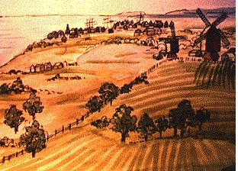
Middle Colonies
Colonies- New York, New Jersey, Pennsylvania, Delaware
Climate/Geography – The Middle colonies spanned the Mid-Atlantic region of America and were temperate in climate with warm summers and cold winters. Geography ranged from coastal plains along the coastline, piedmont (rolling hills) in the middle, and mountains farther inland. This area had good coastal harbors for shipping. Climate and land were ideal for agriculture. These colonies were known as the “breadbasket” because of the large amounts of barley, wheat, oats, and rye that were grown here.
Religion – Religion in the Middle Colonies was varied as no single religion seemed to dominate the entire region. Religious tolerance attracted immigrants from a wide-range of foreign countries who practiced many different religions. Quakers, Catholics, Jews, Lutherans and Presbyterians were among those religious groups that had significant numbers in the middle colonies.
Economy – The Middle Colonies enjoyed a successful and diverse economy. Largely agricultural, farms in this region grew numerous kinds of crops, most notably grains and oats. Logging, shipbuilding, textiles production, and paper-making were also important in the Middle Colonies. Big cities such as Philadelphia and New York were major shipping hubs, and craftsmen such as blacksmiths, silversmiths, cobblers, wheelwrights, wigmakers, milliners, and others contributed to the economies of such cities.
Important Founders:
William Penn (Pennsylvania)
William Penn was born in London, England. He was educated in theology and the law. In his twenties he converted to the Quaker religion and was jailed several times for his resistance to the Church of England. In 1681, he received a royal charter to form a new colony in America, to be named Pennsylvania; he envisioned this territory as a peaceful refuge for members of all religious beliefs (religious tolerance).

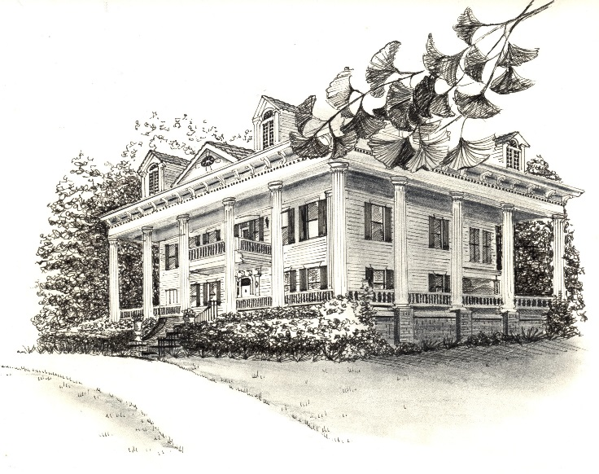
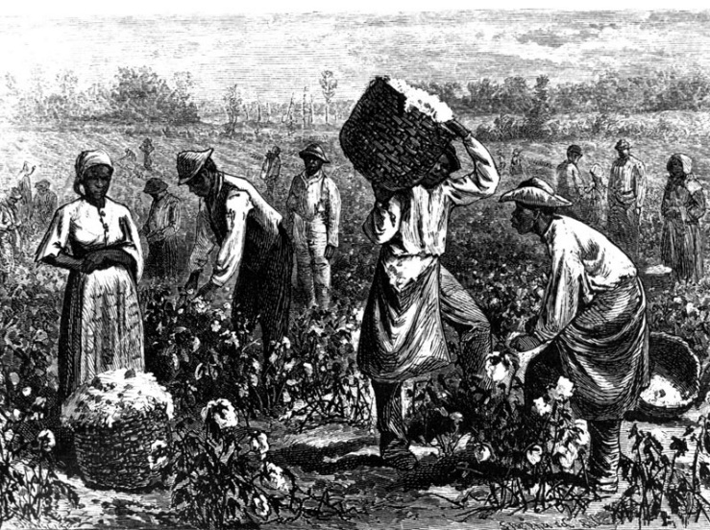
Southern Colonies
Colonies- Maryland, Virginia, North and South Carolina, Georgia
Climate/Geography – The Southern Colonies enjoyed warm climate with hot summers and mild winters. Geography ranged from coastal plains in the east to piedmont farther inland. The westernmost regions were mountainous. The soil was perfect for farming and the growing season was longer than in any other region. Hot summers, however, propagated diseases such as malaria and yellow fever.
Religion – Most people in the Southern Colonies were Anglican (Baptist or Presbyterian), though most of the original settlers from the Maryland colony were Catholic, as Lord Baltimore founded it as a refuge for English Catholics. Religion did not have the same impact on communities as in the New England colonies or the Mid-Atlantic colonies because people lived on plantations that were often distant and spread out from one another.
Economy – The Southern economy was almost entirely based on farming. Rice, indigo, tobacco, sugarcane, and cotton were cash crops. Crops were grown on large plantations where slaves and indentured servants worked the land. In fact, Charleston, South Carolina became one of the centers of the American slave trade in the 1700′s.
Important Founders:
James Oglethorpe (Georgia) As visionary, social reformer, and military leader, James Oglethorpe conceived of and implemented his plan to establish the colony of Georgia as a haven for debtors. His idea began when a friend was placed in prison for not being able to pay his debts which resulted in Oglethorpe’s friend dying of smallpox that he contracted from another prisoner. As a result, Oglethorpe began a campaign for prison reform. Prison reform did not, however, solve the larger plight of the large number of poor people in England. Oglethorpe and several colleagues from the jails committee began exploring the possibility of creating a new colony in America. They believed that if given a chance, England's "worthy poor" could be transformed into farmers, merchants, and artisans.

