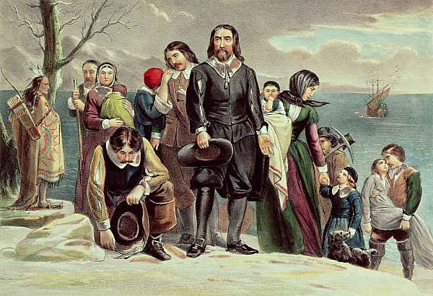  1620 | 1607

- The Jamestown colony was important because…  - The hardships that the Jamestown colonists endured were... | - The Pilgrims decided to leave England and make the dangerous trip to the New World because…
- _______________ __________________ helped the Jamestown colony by…  - People paid for their passage to Jamestown by… | - The Pilgrim’s plan of government was called…  The men agreed to…
Jamestown
Plymouth

