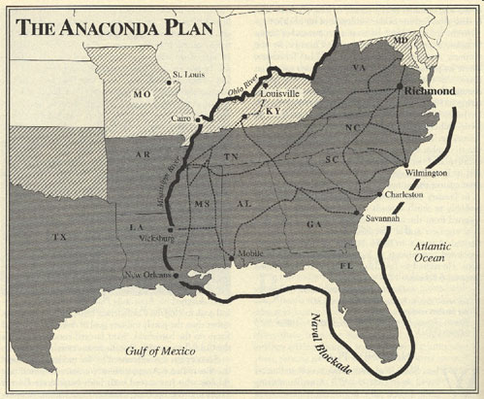 | 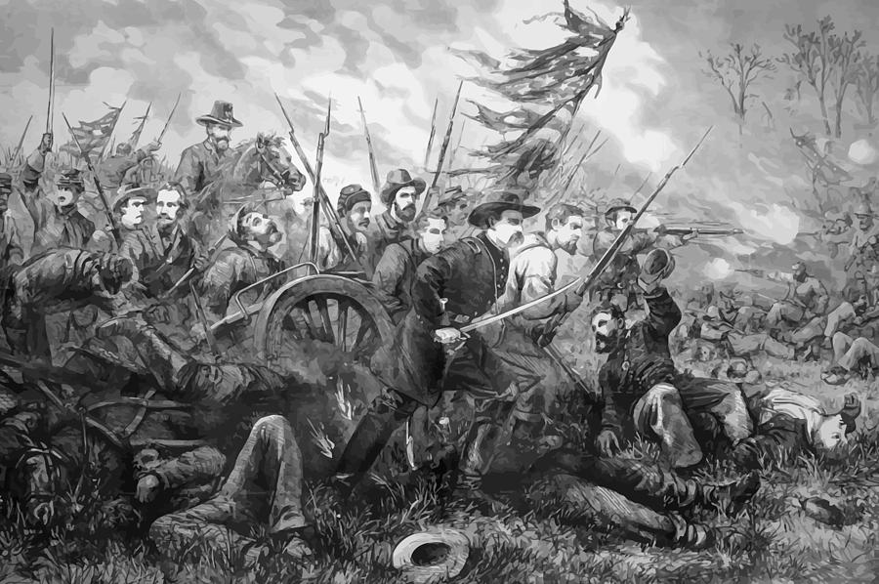

What Happened
Why It’s Important

