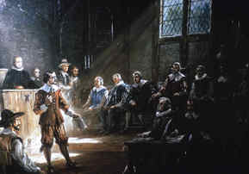
The Virginia House of Burgesses (1619)
The first legislature anywhere in the English colonies in America was in Virginia. This was the House of Burgesses, and it first met on July 30, 1619, at a church in Jamestown. Its first order of business was to set a minimum price for the sale of tobacco. Although the first session was cut short because of an outbreak of malaria, the House of Burgesses soon became a symbol of representative government. Among the 22 members was the governor, who was appointed by officials of the Virginia Company in London. The governor in turn appointed six important members of the colony to be his council. The other 15 members were elected by the colony as a whole, or actually men over 17 who also owned land.
The House of Burgesses, which met at first only once a year, could make laws, which could be vetoed by the governor or the directors of the Virginia Company. This continued to be the standard until 1624, when Virginia became a royal colony. At this time, England took much more control of things in Virginia, restricting the powers of the House of Burgesses.
Through the years leading up to the Revolutionary War, many leaders of the move toward independence made their names in the House of Burgesses. Patrick Henry introduced seven resolutions against the Stamp Act there in 1765.
The fact that the burgesses could make their own laws was very much on the mind of many people in the American colonies, especially when Great Britain continued to pass harsh laws that the colonists viewed as "taxation without representation."
Famous burgesses also included George Washington and Thomas Jefferson.
Foldable Questions:
1. What is the significance of the Virginia House of Burgesses?
2. How is our modern government similar to the Virginia House of Burgesses?

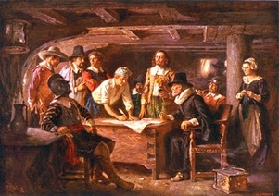
The Mayflower Compact - 1620
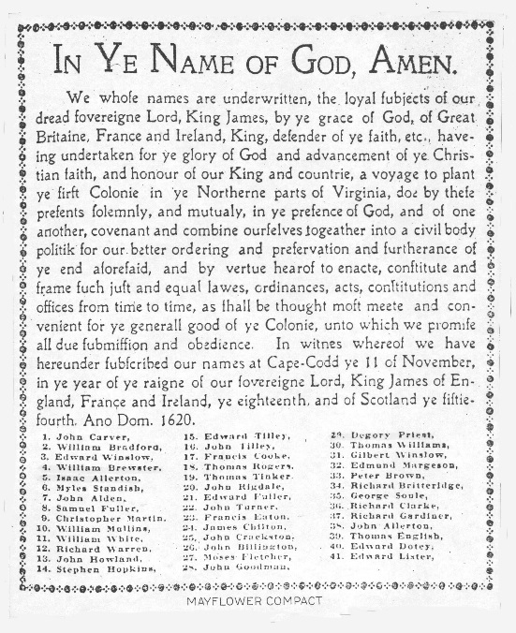
The Mayflower Compact, signed by 41 English colonists on the ship Mayflower on November 11, 1620, was the first written framework of government establishing self-rule in what is now the United States. The compact was drafted to prevent dissent amongst Puritans and non-separatist Pilgrims who had landed at Plymouth a few days earlier.
The Mayflower carried not only the Pilgrims but a few other settlers as well. When it arrived at Cape Cod, several hundred miles north of its planned destination in Virginia owing to storms at sea, the passengers realized they were outside the bounds of the governmental authority they had contracted with in England.
William Bradford, the Pilgrim leader, was alarmed to learn that some of the others felt no obligation to respect the rules of the Pilgrims. In his words, they wanted to "use their own liberty." The male heads of Pilgrim and non-Pilgrim families therefore drew up a compact that bound all signers to accept whatever form of government was established after landing. The compact created a "Civil Body Politic" to enact "just and equal Laws, Ordinances, Acts, Constitutions and Offices." Every adult male had to sign the agreement before going ashore. The compact remained in effect until Plymouth was incorporated into the short-lived Dominion of New England in 1686 and subsequently absorbed into the Massachusetts Bay Colony in 1691.
Foldable Questions:
1. What is the significance of the Mayflower Compact?

2. What was the purpose of the Mayflower Compact?

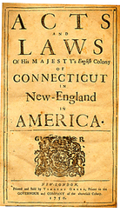
Fundamental Orders of Connecticut (1639)
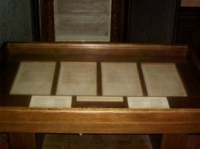
This document was the first written constitution in North America. Written by Puritan clergymen, The Fundamental Orders of Connecticut was adopted by the residents of Hartford, Windsor, and Wethersfield and remained the colony’s law until 1662. It was composed of a preamble and eleven orders, and named God’s requirement for “good and orderly government” to “order and dispose” of peoples’ affairs as the reason for people to “associate and conjoin” themselves into a Commonwealth. The purpose of the Commonwealth was “to maintain and preserve the liberty and purity of the Gospel of our Lord Jesus,” as well as to formulate “Laws, Rules, Orders and Decrees” to guide civil affairs.
The Orders provided for election of a governor and six magistrates. This body had lawmaking, executive, and judicial power. It also included guidelines for representation and paying taxes. It was followed two years later by the Massachusetts Body of Liberties.
Foldable Questions:
1. What is the significance of the Fundamental Orders of Connecticut?

2. How are the ideas of the Fundamental Orders of Connecticut similar to our modern government?

