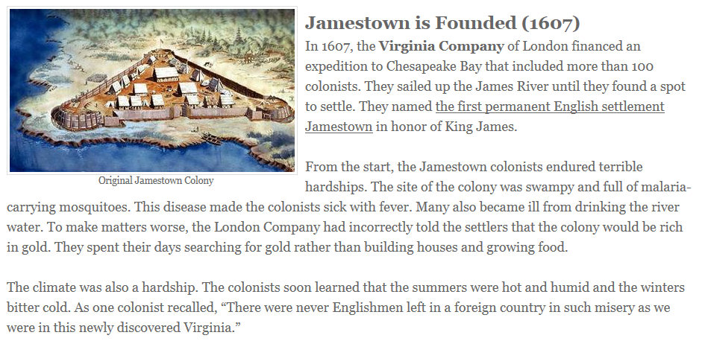
1. What is the significance of the Jamestown colony?
2. What hardships did the Jamestown colonists have to endure?
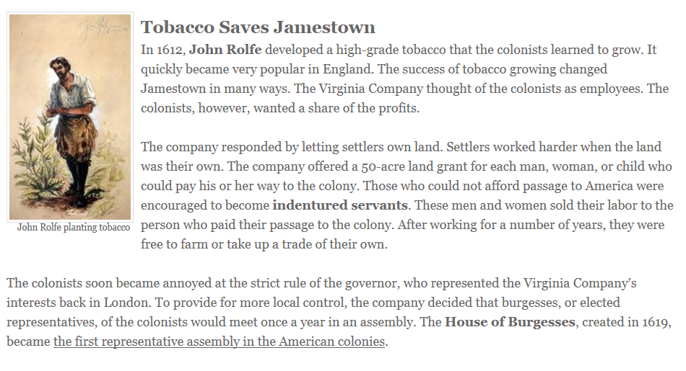
3. How did John Rolfe help the Jamestown colony?
4. How did some people pay for their passage to Jamestown?
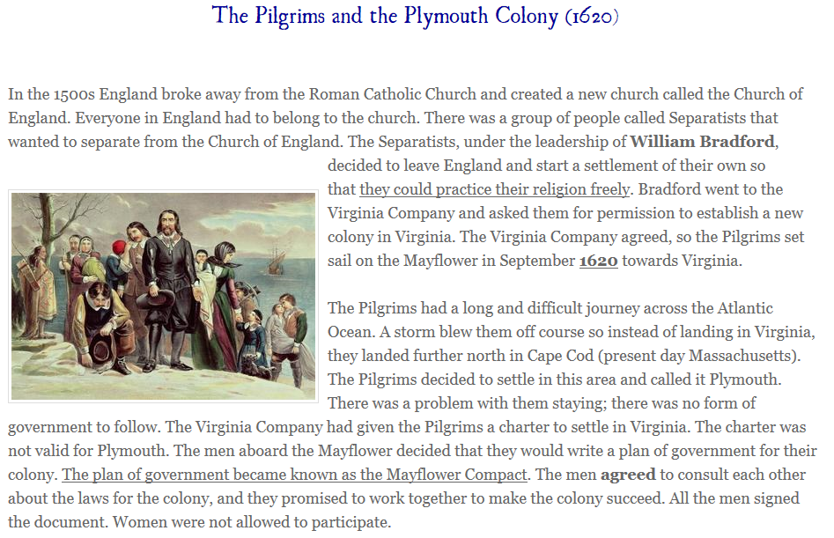
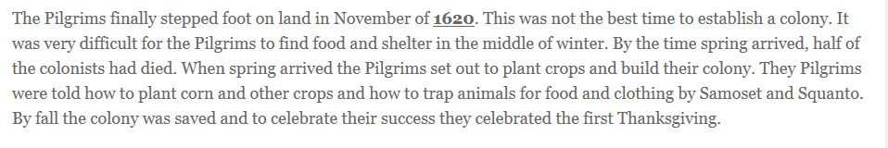

- Why did the Pilgrims decide to leave England and make the dangerous trip to the New World?
2. What was the Pilgrim’s plan of government called? What did the men agree to?

