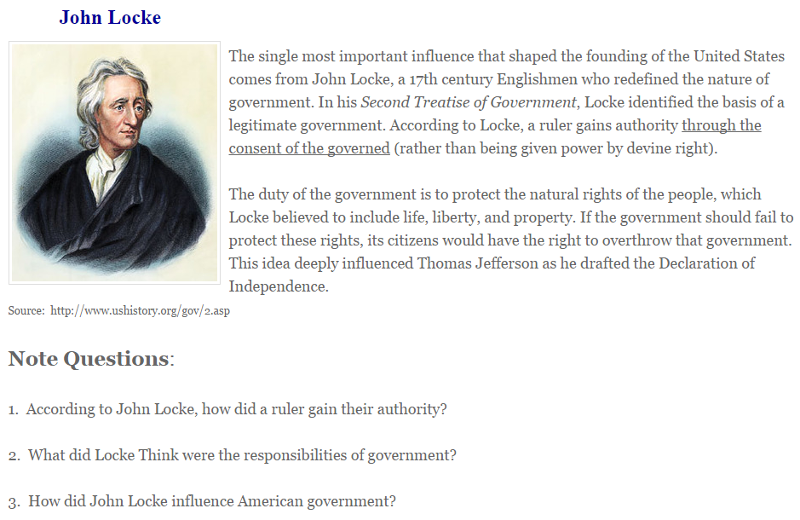

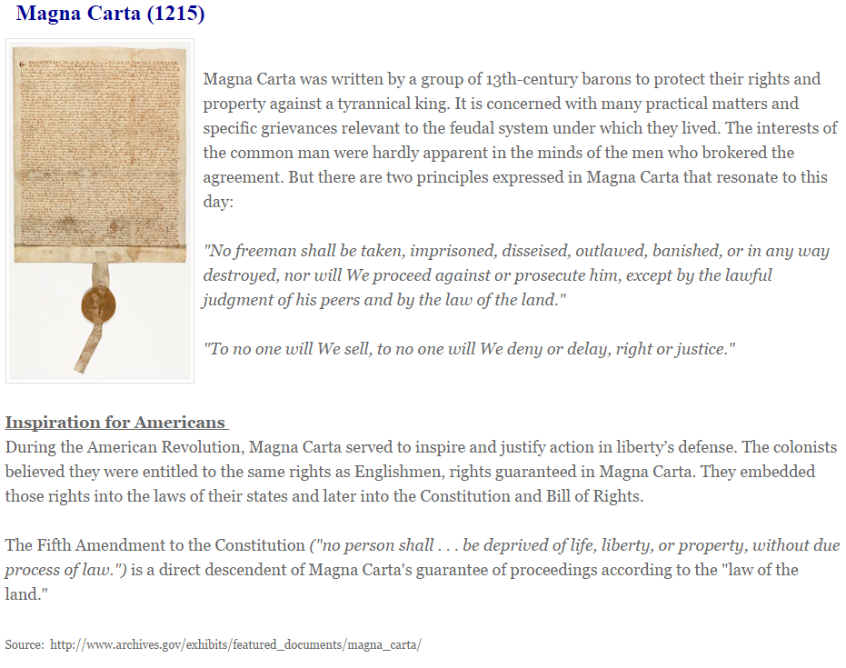
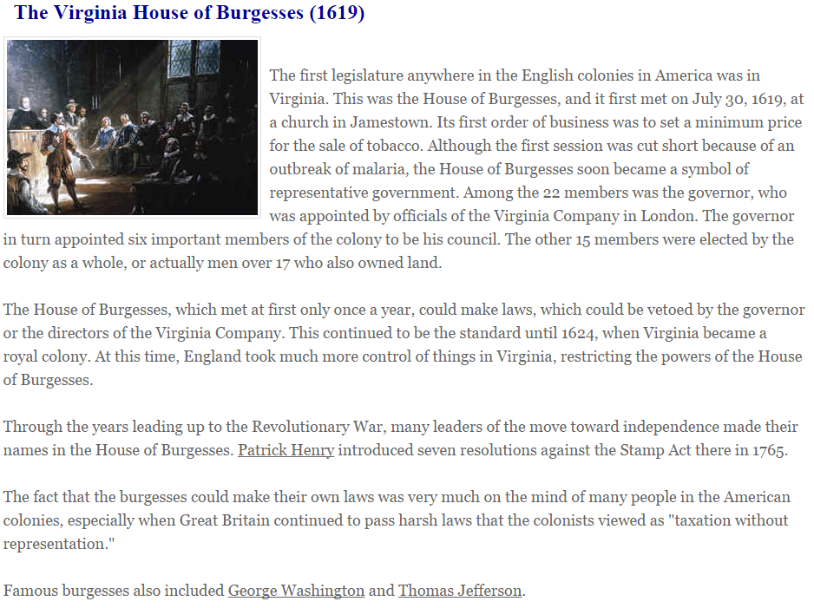
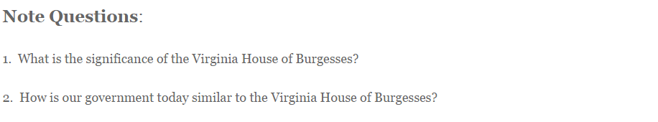
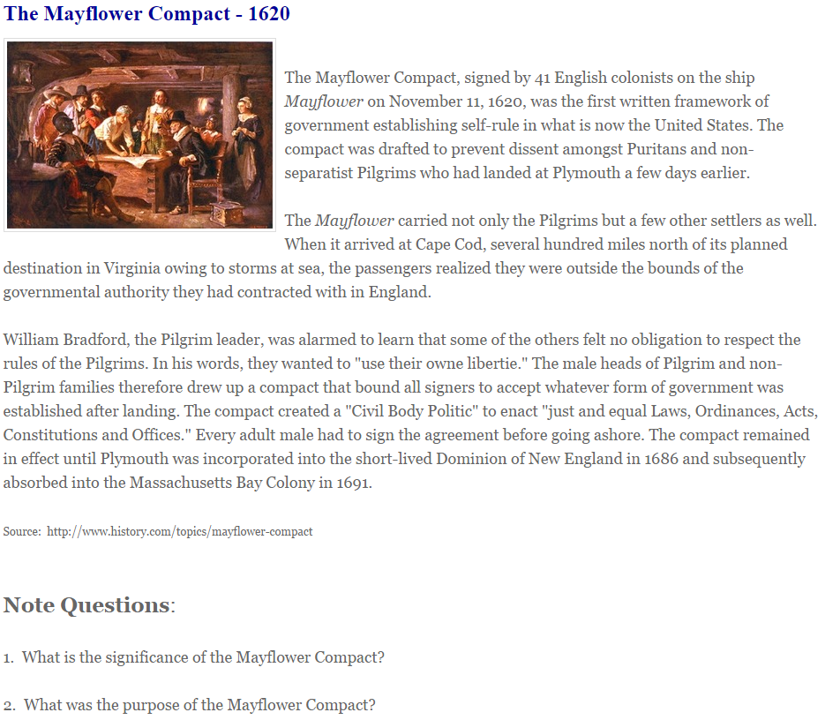

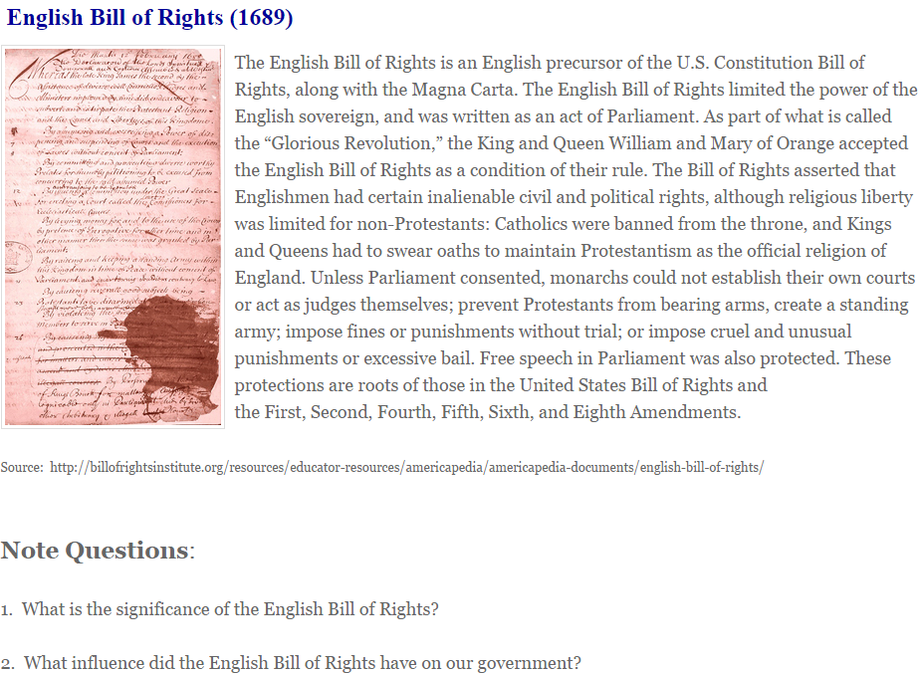

Fundamental Orders of Connecticut (1639)
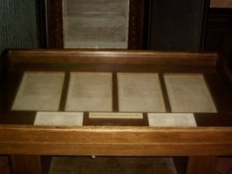
This document was the first written constitution in North America. Written by Puritan clergymen, The Fundamental Orders of Connecticut was adopted by the residents of Hartford, Windsor, and Wethersfield and remained the colony’s law until 1662. It was composed of a preamble and eleven orders, and named God’s requirement for “good and orderly government” to “order and dispose” of peoples’ affairs as the reason for people to “associate and conjoin” themselves into a Commonwealth. The purpose of the Commonwealth was “to maintain and preserve the liberty and purity of the Gospel of our Lord Jesus,” as well as to formulate “Laws, Rules, Orders and Decrees” to guide civil affairs.
The Orders provided for election of a governor and six magistrates. This body had lawmaking, executive, and judicial power. It also included guidelines for representation and paying taxes. It was followed two years later by the Massachusetts Body of Liberties.
Note Questions:
1. What is the significance of the Fundamental Orders of Connecticut?
2. How are the ideas of the Fundamental Orders of Connecticut similar to our government today?

Salutary Neglect
From 1607 to 1763, the unwritten British policy for governing the American colonies was referred to as salutary neglect. Under salutary neglect, enforcement of parliamentary law was deliberately lax, with the stated objective of encouraging colonial prosperity. Colonists were, for the most part, left to look after their own affairs. The practice of salutary neglect for generations, along with the attempt to end this policy and reassert British authority in the 18th century, are identified as important factors leading to the American Revolution.
During this time, the colonists largely were self-governing. Beginning with the House of Burgesses in Virginia, each of the 13 colonies developed its own legislative body. By the 18th century, they were functioning as independent, autonomous governments.
Americans enjoyed personal and religious freedoms not shared by other British subjects. Maryland passed the Act Concerning Religion, or the Maryland Toleration Act, in 1649 to protect religious freedoms and promote tolerance. Similar legislation in Pennsylvania attracted settlers from the Quaker community.
Under salutary neglect, colonists did not feel the influence of the British government and culture. These developments led to a growing sense of American identity, distinct from Britain. Americans had become used to the idea of self-governance and began to think of themselves as British subjects in name only.
Note Questions:
1. What is salutary neglect?
2. How did this salutary neglect shape life in America?

